Sequence Diagram:
Event Creation:
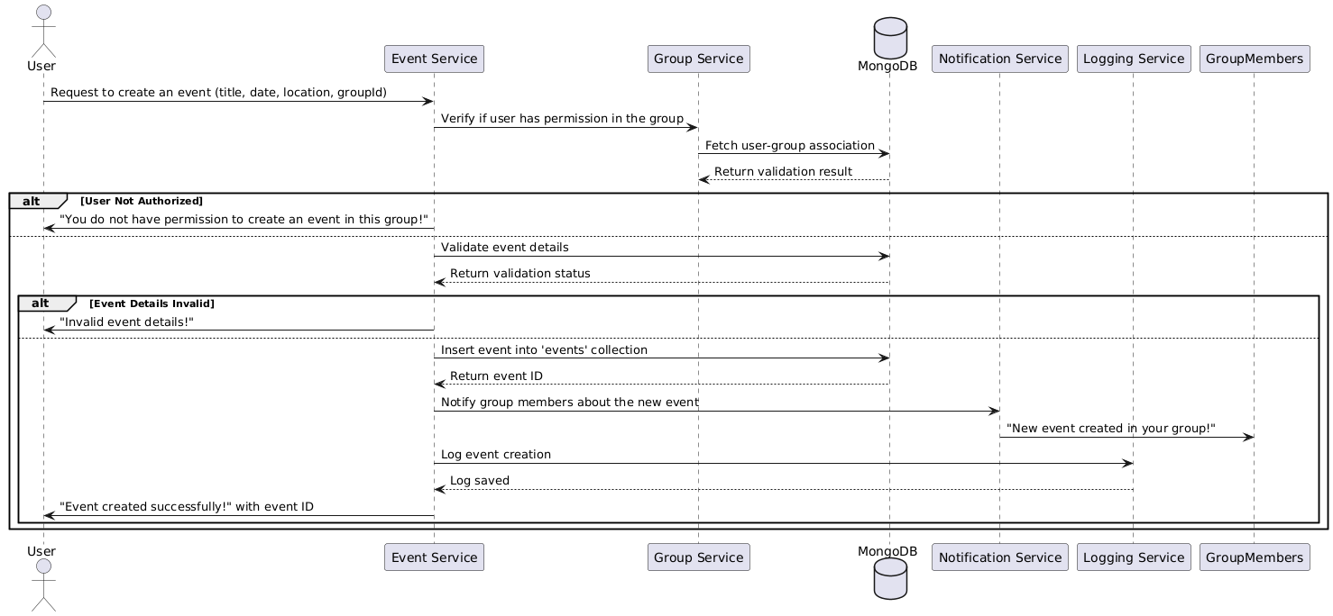

Database
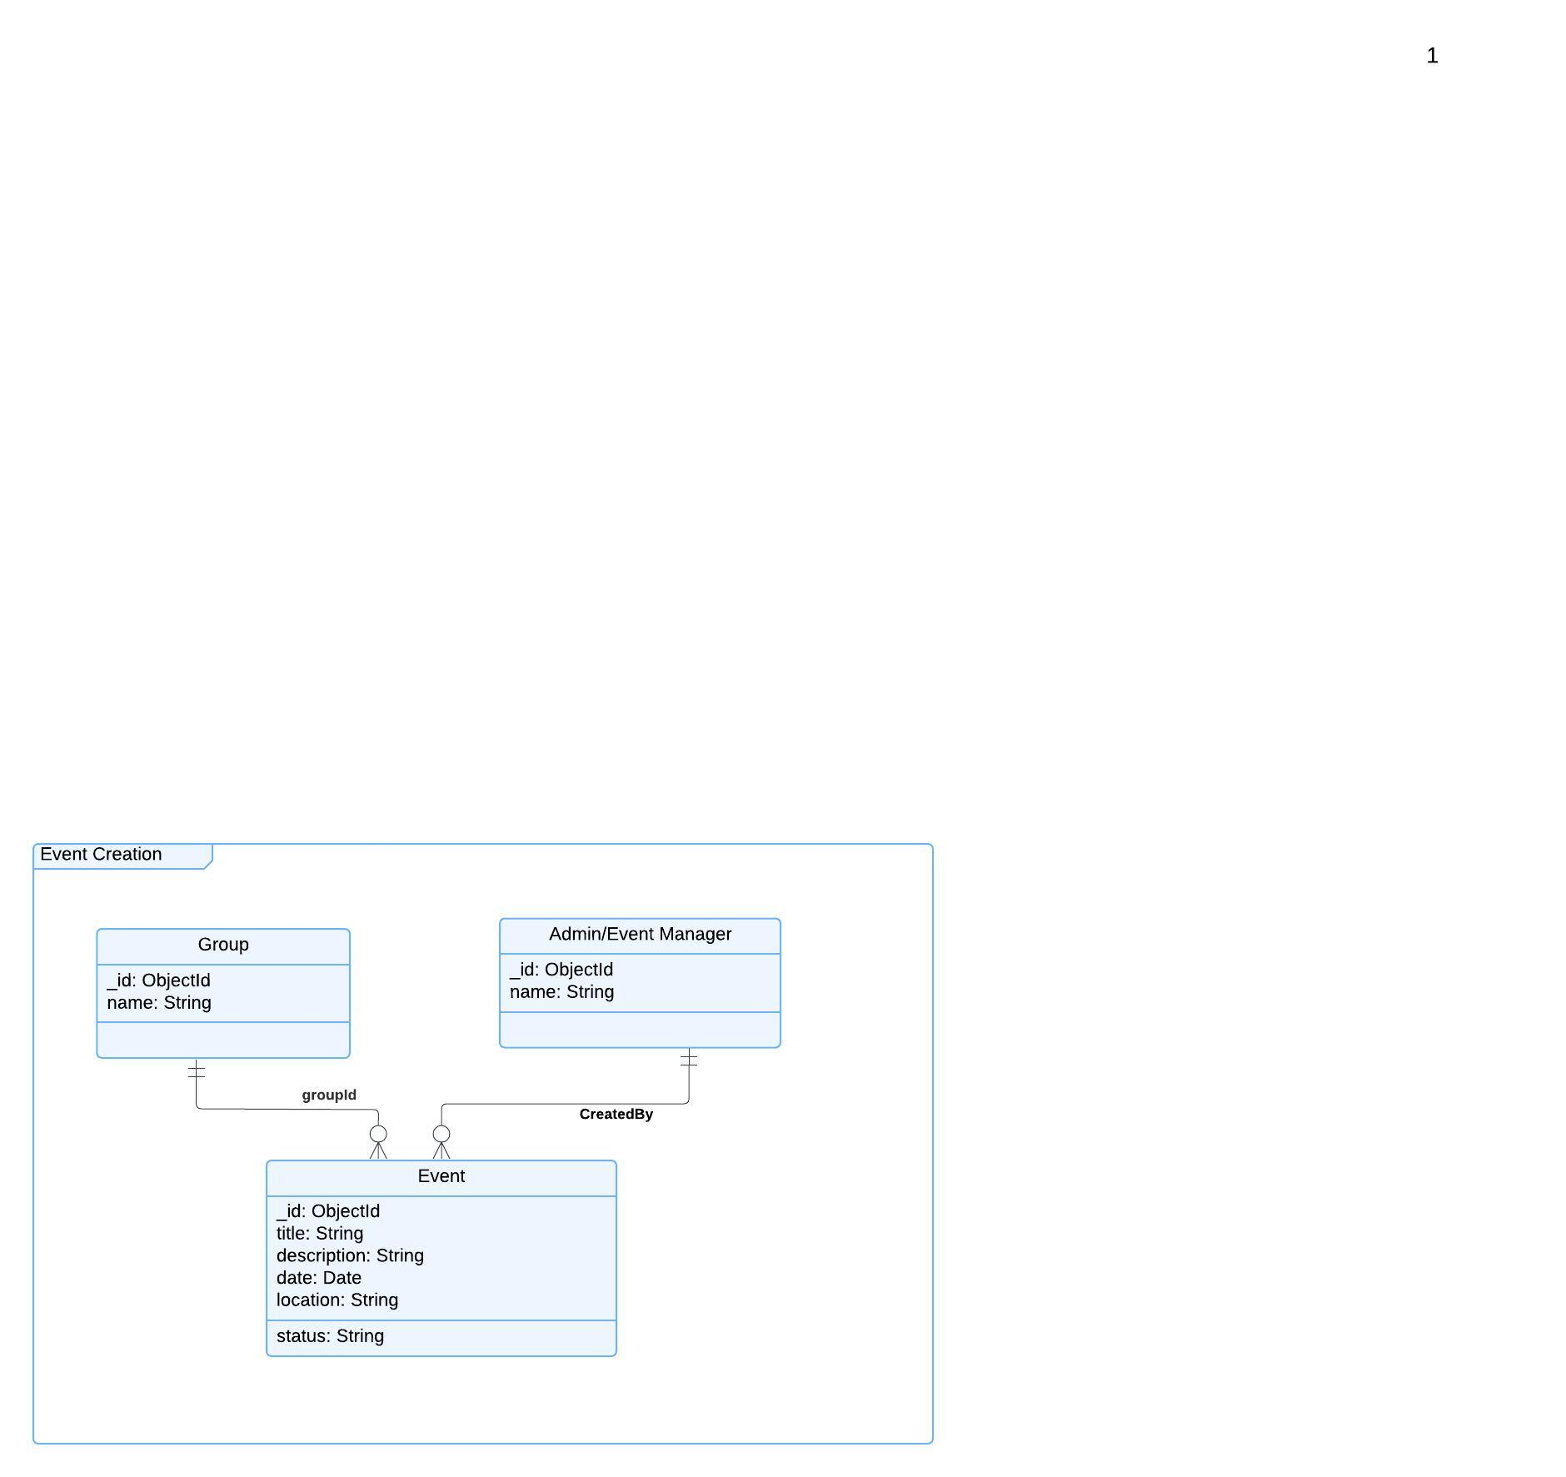

Functional Requirements (FRs)
- FR1: The system shall validate event details such as title, date, location, and category.
- FR2: Only group admins and moderators shall be able to create events.
- FR3: Events shall be linked to the group they belong to.
- FR4: The system shall allow events to be created as "draft" or "published".
Non-Functional Requirements (NFRs)
- NFR1: The system shall support at least 10,000 concurrent event creations.
- NFR2: Event creation should not exceed 3 seconds.

